

AP® Physics C
1986 Free Response Questions

The materials included in these files are intended for use by AP teachers for course and exam preparation in the classroom; permission for any other use must be sought from the Advanced Placement Program®. Teachers may reproduce them, in whole or in part, in limited quantities, for face-to-face teaching purposes but may not mass distribute the materials, electronically or otherwise. These materials and any copies made of them may not be resold, and the copyright notices must be retained as they appear here. This permission does not apply to any third-party copyrights contained herein.

These materials were produced by Educational Testing Service® (ETS®), which develops and administers the examinations of the Advanced Placement
Program for the College Board. The College Board and Educational Testing Service (ETS) are dedicated to the principle of equal opportunity, and their
programs, services, and employment policies are guided by that principle.

The College Board is a national nonprofit membership association dedicated to preparing, inspiring, and connecting students to college and opportunity.
Founded in 1900, the association is composed of more than 4,200 schools, colleges, universities, and other educational organizations. Each year, the
College Board serves over three million students and their parents, 22,000 high schools, and 3,500 colleges, through major programs and services in
college admission, guidance, assessment, financial aid, enrollment, and teaching and learning. Among its best-known programs are the SAT®, the
PSAT/NMSQT®, and the Advanced Placement Program® (AP®). The College Board is committed to the principles of equity and
excellence, and that commitment is embodied in all of its programs, services, activities, and concerns.

APIEL is a trademark owned by the College Entrance Examination Board. PSAT/NMSQT is a registered trademark jointly owned by the College Entrance Examination Board and the National Merit Scholarship Corporation. Educational Testing Service and ETS are registered trademarks of Educational Testing Service.

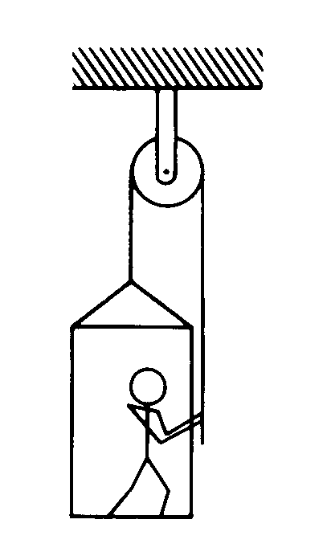
1986M1. The figure above shows an 80-kilogram person standing on a 20-kilogram platform suspended by a rope passing over a stationary pulley that is free to rotate. The other end of the rope is held by the person. The masses of the rope and pulley are negligible. You may use g = 10 m/ s². Assume that friction is negligible, and the parts of the rope shown remain vertical.
a. If the platform and the person are at rest, what is the tension in the rope?

The person now pulls on the rope so that the acceleration of the person and the platform is 2 m/s² upward.
b. What is the tension in the rope under these new conditions?
c. Under these conditions, what is the force exerted by the platform on the person?

After a short time, the person and the platform reach and sustain an upward velocity of 0.4 m/ s.
d. Determine the power output of the person required to sustain this velocity.

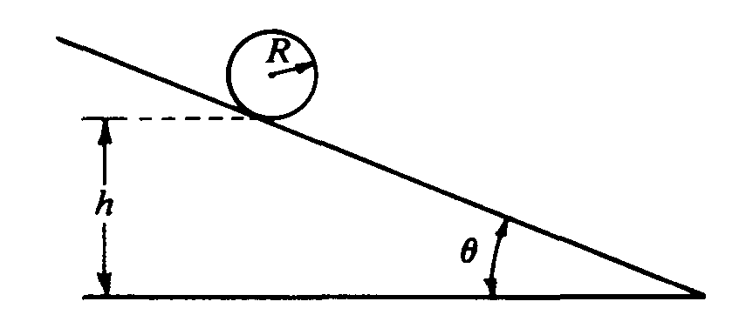
1986M2. An inclined plane makes an angle of θ with the horizontal, as shown above. A solid sphere of radius R and mass M is initially at rest in the position shown, such that the lowest point of the sphere is a vertical height h above the base of the plane. The sphere is released and rolls down the plane without slipping. The moment of inertia of the sphere about an axis through its center is 2MR²/5. Express your answers in terms of M, R. h, g, and B.
a. Determine the following for the sphere when it is at the bottom of the plane:
i. Its translational kinetic energy
ii. Its rotational kinetic energy
b. Determine the following for the sphere when it is on the plane.
i. Its linear acceleration
ii. The magnitude of the frictional force acting on it

The solid sphere is replaced by a hollow sphere of identical radius R and mass M. The hollow sphere, which is released from the same location as the solid sphere, rolls down the incline without slipping.
c. What is the total kinetic energy of the hollow sphere at the bottom of the plane?
d. State whether the rotational kinetic energy of the hollow sphere is greater than, less than, or equal to that of the solid sphere at the bottom of the plane. Justify your answer.

1986M3. A special spring is constructed in which the restoring force is in the opposite direction to the displacement, but is proportional to the cube of the displacement; i.e., F = -kx³
This spring is placed on a horizontal frictionless surface. One end of the spring is fixed, and the other end
is fastened to a mass M. The mass is moved so that the spring is stretched a distance A and then released.
Determine each of the following in terms of k, A, and M.
a. The potential energy in the spring at the instant the mass is released
b. The maximum speed of the mass
c. The displacement of the mass at the point where the potential energy of the spring and the kinetic energy of the mass are equal

The amplitude of the oscillation is now increased:
d. State whether the period of the oscillation increases, decreases, or remains the same. Justify your answer.
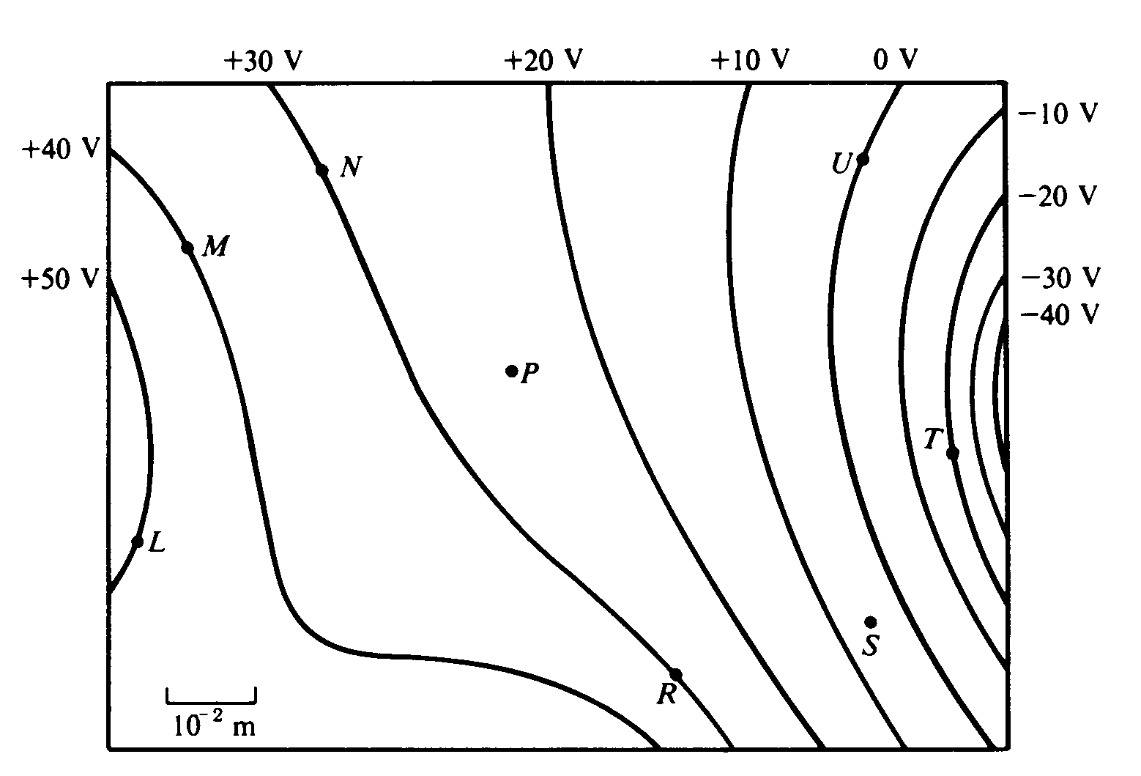
1986E1. Three point charges produce the electric equipotential lines shown on the diagram above.
a. Draw arrows at points L, N. and U on the diagram to indicate the direction of the electric field at these points.
b. At which of the lettered points is the electric field E greatest in magnitude? Explain your reasoning.
c. Compute an approximate value for the magnitude of the electric field E at point P.
d. Compute an approximate value for the potential difference, V_{M} - V_{S}, between points M and S.
e. Determine the work done by the field if a charge of +5 x 10⁻¹² coulomb is moved from point M to point R.
f. If the charge of +5 x 10⁻¹² coulomb were moved from point M first to point S, and then to point R, would the answer to (e) be different, and if so, how?

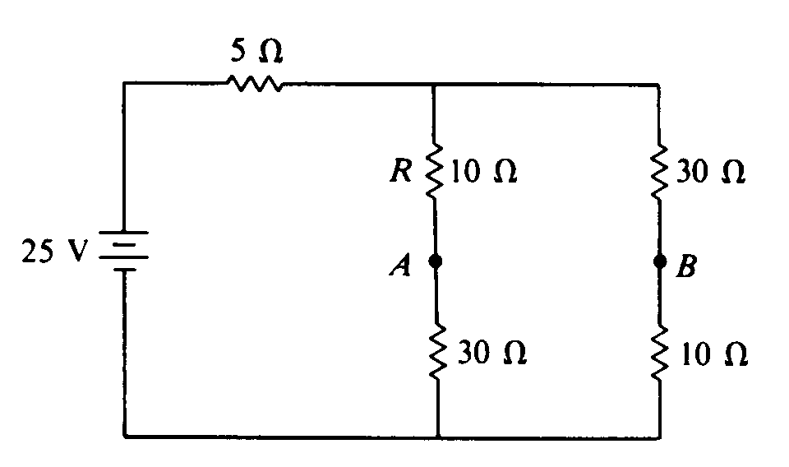
1986E2. Five resistors are connected as shown above to a 25-volt source of emf with zero internal resistance.
a. Determine the current in the resistor labeled R.

A 10-microfarad capacitor is connected between points A and B. The currents in the circuit and the charge on the capacitor soon reach constant values. Determine the constant value for each of the following.
b. The current in the resistor R
c. The charge on the capacitor

The capacitor is now replaced by a 2.0-henry inductor with zero resistance. The currents in the circuit again reach constant values. Determine the constant value for each of the following.
d. The current in the resistor R
e. The current in the inductor
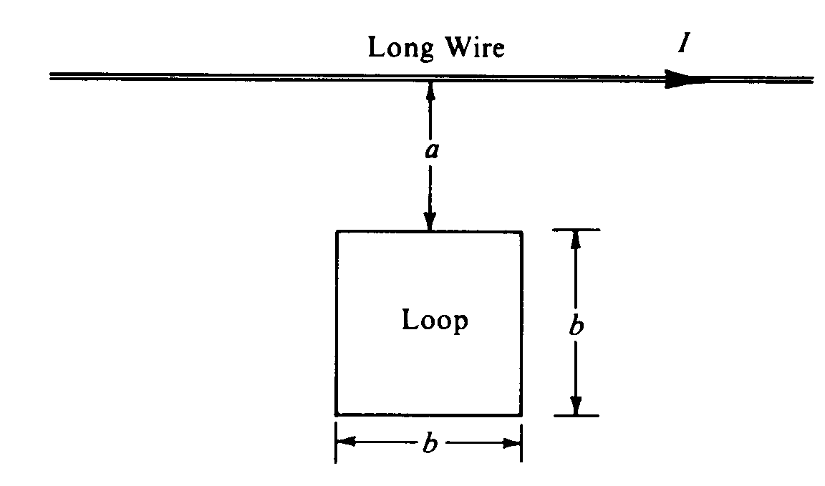

1986E3. A long wire carries a current in the direction shown above. The current I varies linearly with time t as follows: I = ct, where c is a positive constant. The long wire is in the same plane as a square loop of wire of side b, as shown in the diagram. The side of the loop nearest the long wire is parallel to it and a distance a from it. The loop has a resistance R and is fixed in space.
a. Determine the magnetic field B at a distance r from the long wire as a function of time.
b. Indicate on the diagram the direction of the induced current in the loop.
c. Determine the induced current in the loop.
d. State whether the magnetic force on the loop is toward or away from the wire.
e. Determine the magnitude of the magnetic force on the loop as a function of time.

